ZECPATH PRODUCT & AI OVERVIEW

Project Prepared By Suhail TP

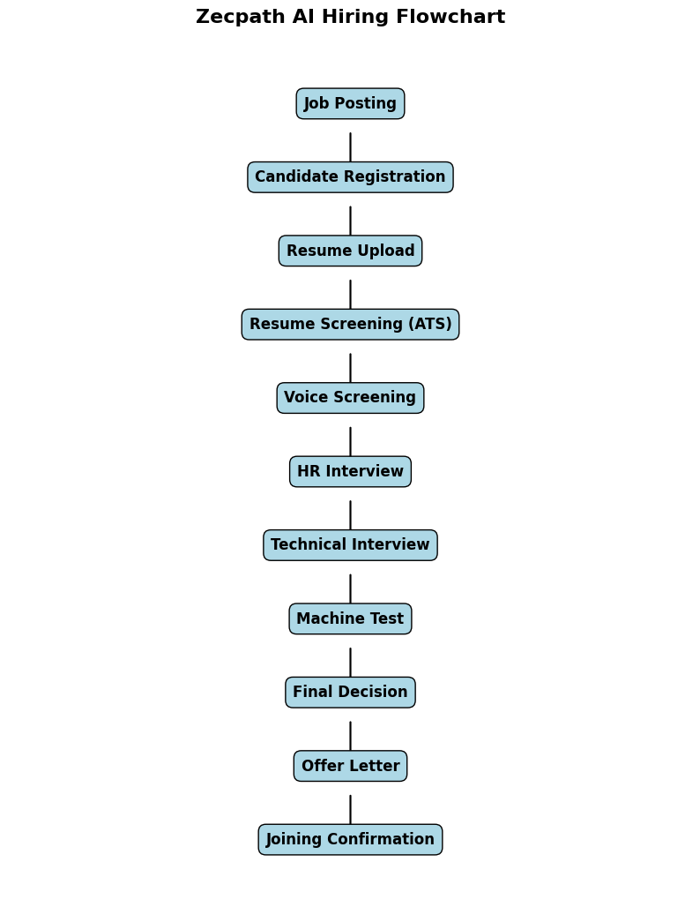

Complete Hiring Flow Explanation

1. Job Posting
Recruiters create job roles with skills, experience, salary, etc.

2. Resume Submission
Candidates upload resumes (PDF/DOC).

3. AI ATS Screening
AI reads resumes and extracts:
- Skills
- Experience
- Education
- Keywords

4. AI Voice Screening
Shortlisted candidates get automated AI calls:
- Self-introduction
- Experience
- Salary expectation

5. HR Interview AI
AI HR conducts interview:
- Strengths / weaknesses
- Culture fit
- Communication skills

6. Technical Interview AI
Role-based questions:
- Concepts
- Problem solving
- Architecture

7. Machine Test AI
Live coding / real tasks:
- Debugging
- Development
- Design

8. Final Decision AI
Combines all scores:
- ATS
- HR
- Technical
- Behavior

9. Offer Automation
Selected candidates get:
- Offer letter
- Salary details
- Joining date

List of All AI Modules

1. Resume Parser AI

Extracts:
- Name
- Skills
- Experience
- Education

2. ATS Scoring Engine
Ranks candidates using:
- Skill match
- Experience level
- Keywords

3. Eligibility Engine
Filters candidates based on:
- Criteria
- Cut-off scores

4. AI Voice Screening
Automated voice calls for screening.

5. Speech-to-Text Engine
Converts voice answers → text.

6. AI Answer Analysis Engine

Analyzes candidate responses.

7. HR Interview AI
Conducts HR interviews automatically.

8. Communication Analysis AI
Measures:
- Fluency
- Grammar
- Confidence

9. Behavior Analysis AI
Detects:
- Eye movement
- Stress
- Focus

10. Technical Interview AI
Asks technical questions dynamically.

11. Adaptive Question Engine

Generates follow-up questions.

12. Technical Scoring Engine
Scores technical performance.

13. Machine Test AI
Assigns real-world tasks.

14. Coding Evaluation AI
Checks:
- Logic
- Accuracy
- Optimization

15. Malpractice Detection AI
Detects cheating:
- Tab switching
- External help

16. Decision Engine AI
Combines all scores → decision.

17. Salary Negotiation AI
Handles compensation discussions.
18. Offer Letter Generator AI
Creates branded offer letters.

AI Responsibilities Overview
Introduction
Zecpath is an AI-powered hiring platform designed to automate the entire recruitment lifecycle from job posting to offer release. Artificial Intelligence drives each stage to reduce manual recruiter effort and improve hiring accuracy.

Resume Screening Automation
AI Resume Parser extracts structured data from resumes. ATS scoring ranks candidates based on job fit, ensuring unbiased shortlisting.

Candidate Screening
AI voice bots conduct initial screening calls, collecting candidate details like experience, salary expectations, and availability.

Interview Automation
AI HR and Technical Interviewers conduct structured interviews, ask dynamic questions, and analyze responses in real time.

Behavior & Communication Analysis
Vision AI and speech analytics evaluate:
- Confidence
- Fluency
- Eye contact

Skill Validation
Machine test AI evaluates real technical ability through coding and task execution.
Decision Intelligence
AI combines ATS, HR, technical, and behavioral scores to make final hiring recommendations.

Offer & Onboarding Automation
AI generates offer letters, confirms joining, and automates communication.

Business Impact
- Faster hiring
- Reduced recruiter workload

